Introduction to Information Security
Lab 2
The need for security , Identifying Business Needs For security, Analyzing
Simulating Common Attacks and different Threats
Instructor: Ms. Wasifa Kanwal

Lab Objectives
By the end of this lab, you will be able to:
- Identify different types of cyber attacks with simple real-world examples.
- Explain what threats are and classify types of threats.
- Understand the difference between threats and attacks.
- Safely simulate common attacks (Phising, DOS, Password Attack).

Understanding Security Attacks :
Cyber attacks are deliberate attempts by hackers to damage, steal, or gain unauthorized access to systems or data. Attacks can be classified as active and passive attacks. An attack will have a motive and will follow a method when the opportunity arises.

Types of Attack:
- Active Attack: Active attacks aim to manipulate system resources or impact their operation.
- Passive Attack: Passive attacks aim to extract sensitive information from a system without affecting its resources.

Common Types of Attacks:
Type of Attack | Description | Real-life Example
Phishing | Fake emails or messages to steal info | “You’ve won an iPhone!” email with a fake link
Malware | Harmful software that infects your system | Clicking an unsafe link downloads a virus
DoS Attack | Overloads a server to make it unavailable | University website goes down during registration
Password Attack | Cracking or stealing passwords | Using “123456” makes your account easy to hack
Man-in-the-Middle | Attacker intercepts data between two parties | Hacking public Wi-Fi communications
SQL Injection | Injecting malicious code into databases | Hackers extract login info from a website

Threats:
A threat is a possible security violation that might exploit the vulnerability of a system or asset. The origin of the threat may be accidental, environmental (natural disaster), human negligence, or human failure.
Recognizing and understanding these threats is crucial for implementing effective security measures. By identifying potential threats, you can better protect your sensitive information and maintain the integrity of your digital assets. Effective threat management is key to maintaining a secure and resilient cyber security posture.

Types of Threats
- Unstructured Threats: They are typically executed by inexperienced individuals using easily accessible hacking tools like shell scripts and password crackers.
- Structured Threat: A structured threat involves an organized attempt to breach a specific network or organization. These threats come from highly motivated and technically proficient hackers.
- External Threats: External threats might come from individuals or organizations working outside the company. They have unauthorized access to the computer systems and network. They typically enter a network via the Internet.
- Internal Threat: Internal dangers occur due to authorized network access, whether through a server account or physical access.

Simulating Common Attacks:

Phishing (simulation (local email analysis))

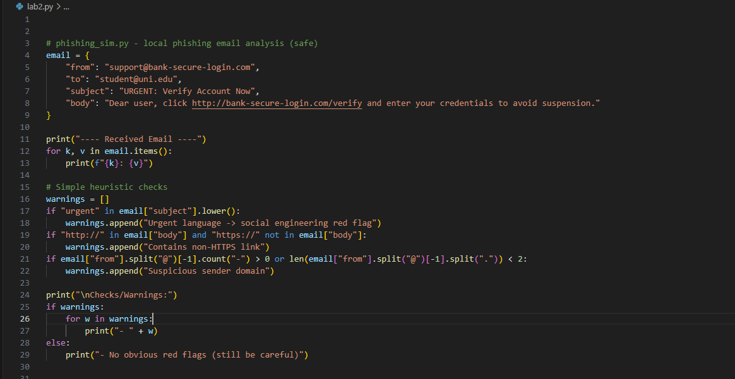

- Denial of Service (DoS)
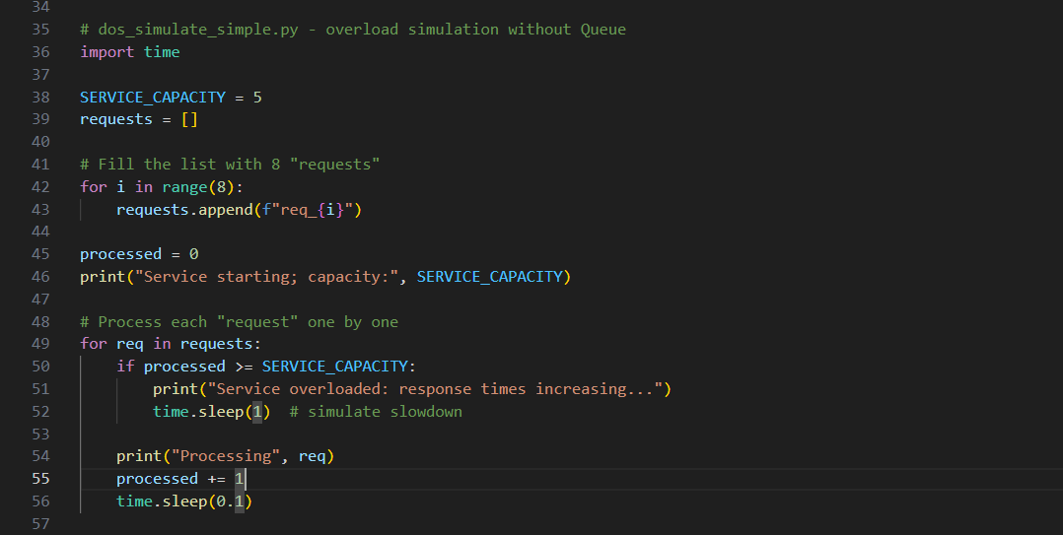

- Password Attack
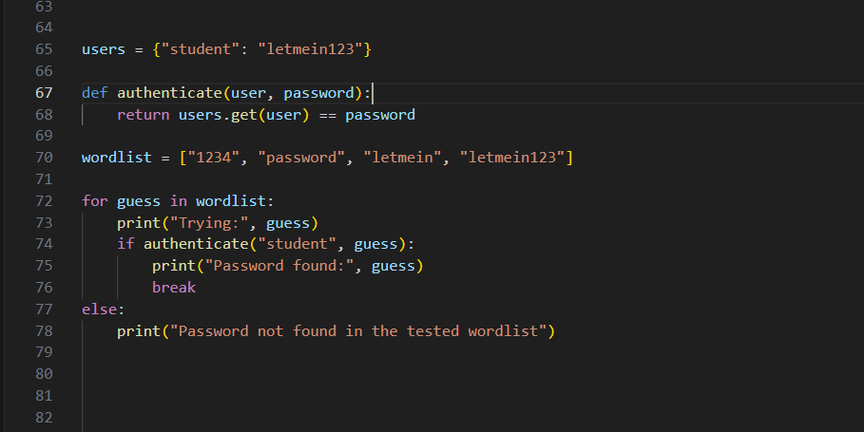

- Man-in-the-Middle (MITM)

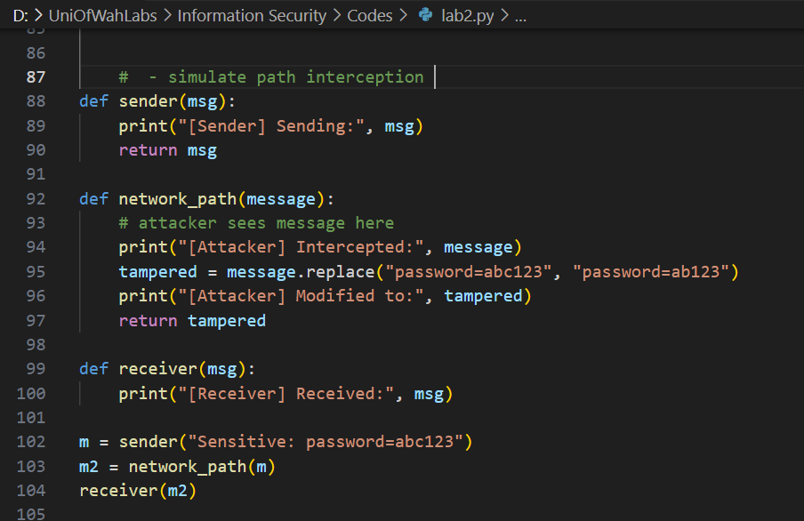

Lab Assignment 3: Deadline:10/29/25 10:00pm
Information Security CS 3B

Assignment Task 1: Smart Email Security Filter
- The program should ask the user to enter the subject and body for 3 different emails.
- The script must search each email (subject + body) for the following suspicious words:
urgent, verify, click here, account
- If any of these words appear in the email, they should be flagged.
- Count how many suspicious words appear in each email and assign a risk score based on the number of red flags:
- 0 red flags → Low Risk
- 1 red flag → Medium Risk
- 2 or more red flags → High Risk
- Display the result for each email, showing:
- The email number
- The suspicious words found (if any)
- The total number of red flags
- The final risk level (Low, Medium, or High)
- After analyzing all 3 emails, print an overall summary that includes:
- Total number of emails analyzed
- Number of Low Risk, Medium Risk, and High Risk emails

Assignment Task 2:
Write a Python program that has following functions:
- sender(msg) → compute checksum = sum(ord(c) for c in msg) as integer; return a string packet: "<msg>|<checksum>" and print it.
- network(packet, tamper=False) → if tamper is True, change the message text (e.g., replace "abc123" with "ab123") but do not update checksum; print what attacker sends on.
- receiver(packet) → split on "|" to get msg and checksum_str; compute checksum of received msg and compare to checksum_str. If equal print "OK", else print "Tampered!".
Demonstrate both cases: one with tamper=False and another with tamper=True.

Assignment Task 3:
Write a Python program that:
- Given a list requests where each request is a tuple (req_id, source) — source can be an IP-like string (e.g., "10.0.0.5").
- Service capacity (max processed requests overall) = capacity.
- Per-source maximum allowed requests = per_source_limit. If a source sends more than per_source_limit requests, mark that source blocked and skip its future requests.
- Process requests in order. For each request:
- If source is blocked → print Blocked <req_id> from <source> and skip.
- Else if processed < capacity → print Processing <req_id> from <source> and count it.
- Else → print Server overloaded! and stop processing.
- At the end print a short summary: processed count and blocked sources.
Note: Use only those concepts of python we covered in lab.

